ECE Department

Electronics Lab

ECE471

Optical Communication Project  
 **“Erbium Doped Fiber Amplifier Modelling”**

|  |  |
| --- | --- |
| Student Name : | ياسمين ممدوح حنفي عبد الرحمن علمي ذكي  بسمه شوقي محمود نورهان أحمد ادريس أحمد سامي عبدالغفار معاذ سعيد حسن |

The absorption and emission cross section using plot digitizer: 1

Ppump and Psout Vs fiber length at wavelength 1550 nm: 2

Gain Vs fiber length at different pump power: 3

Psout Vs Psin & Gain Vs Psin: 4

Gain Vs lamda(C-band) at Ppump= 0.5w and Psin= 1mw : 5

Psout with ASE Vs lamda(C-band): 6

clc  
clear  
close all  
r=5e-06;  
gammap=0.4;  
gammas=0.8;  
N=1e25;  
A=pi.*r^2;  
lamdap=1480e-09;  
segmaep=0.7899e-25;  
segmaap=1.950e-25;  
lamdas=1550e-09;  
segmaes=3.084e-25;  
segmaas=2.277e-25;  
t=10e-03;  
c=3e8;  
h=6.626e-34;  
deltalamda=0.1e-09;

## The absorption and emission cross section using plot digitizer:

[v1,T1,vT1]=xlsread('data1.xlsx');  
x1=v1(:,1);y1=v1(:,2);  
figure  
plot(smooth(x1),smooth(y1),'b','linewidth',2)  
hold on  
[v2,T2,vT2]=xlsread('data2.xlsx');  
x2=v2(:,1);y2=v2(:,2);  
plot(smooth(x2),smooth(y2),'r','linewidth',2); grid on;  
xlabel('wavelength(nm)');  
ylabel('10^-21 cm^2');  
legend('abs. cross section','em. cross section')  
title('The absorption and emission cross section using plot digitizer')

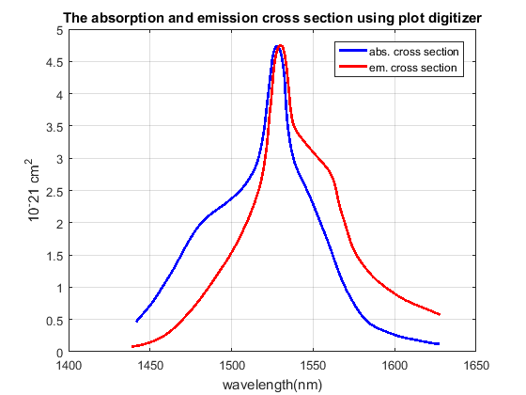

## Ppump and Psout Vs fiber length at wavelength 1550 nm:

psindB=-40:10:10;  
psin=10.^(psindB./10)*10^-3;  
Ppump_in=[0.5 0.001];  
[l,p]=ode45('dP_dz',(0:50),Ppump_in);  
[maxValue,maxIndex]=max(p(:,2));  
[maxValuep,maxIndexp]=max(10*log10(p(:,2)./0.001));  
figure  
plot(l,p(:,1),'linewidth',1.5);  
hold on  
plot(l,p(:,2),'linewidth',1.5);  
xlabel('fiber length(m)');  
ylabel('optical powers(W)');  
legend('Ppump','Psout')  
title('Ppump and Psout Vs fiber length at wavelength 1550 nm')

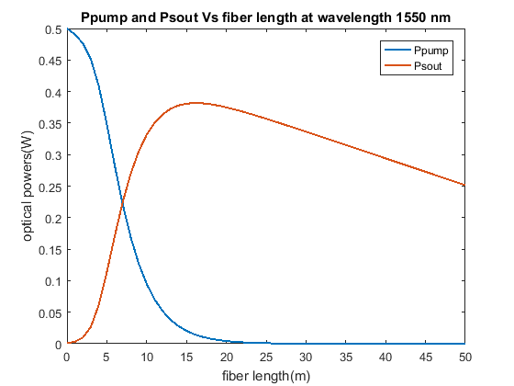

## Gain Vs fiber length at different pump power:

ppump=0.1:0.1:0.5;  
figure  
hold on  
for j=1:1:length(ppump)  
Ppump_in=[ppump(j) 0.001];  
[l,p]=ode45('dP_dz',(0:50),Ppump_in);  
gainp=(p(:,2)./0.001);  
gainpdB=10*log10(gainp);  
plot(smooth(l),smooth(gainpdB),'linewidth',1.5)  
end  
optlength=l(maxIndexp);  
plot(optlength,maxValuep,'*','linewidth',1.5)  
hold off  
xlabel('fiber length(m)');  
ylabel('Gain(dB)');  
legend('Ppump=0.1','Ppump=0.2','Ppump=0.3',...  
'Ppump=0.4','Ppump=0.5','opt.length=15.8811 m')  
title('Gain Vs fiber length at different pump power')

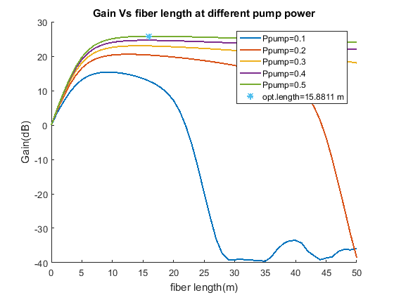

## Psout Vs Psin & Gain Vs Psin:

psindB=-40:1:40;  
psin=10.^(psindB./10)*10^-3;  
psout=[];  
Gain=[];  
for i=1:1:length(psin)  
Ppump_in=[0.5 psin(i)];  
[l,p]=ode45('dP_dz',(0:50),Ppump_in);  
if psin(i)<= 0.001  
psout=[psout max(p(:,2))];  
elseif psin(i)> 0.001  
psout=[psout p(maxIndex,2)];  
else  
end  
psoutdB=10*log10(psout);  
Gain=[Gain (psout(i)./psin(i))];  
GaindB=10*log10(Gain);  
end  
figure  
semilogy(smooth(psin),smooth(psout),'linewidth',1.5)  
xlabel('Psin(w)');  
ylabel('Psout(w)');  
title('Psout Vs Psin')  
ylim([min(psout) max(psout)])  
figure  
semilogy(smooth(psindB),smooth(GaindB),'linewidth',1.5)  
xlabel('Psin(w)');  
ylabel('Gain(dB)');  
title('Gain Vs Psin')

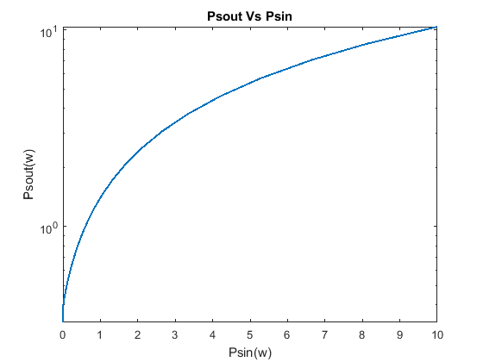

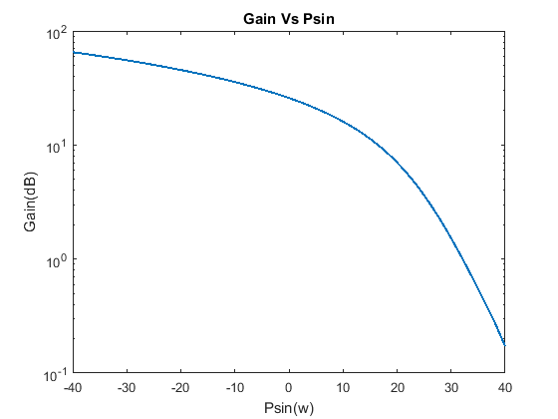

## Gain Vs lamda(C-band) at Ppump= 0.5w and Psin= 1mw :

[v,T,vT]=xlsread('abs_em_values.xlsx');  
x=v(:,1);y=v(:,3); z=v(:,2);  
Ppump_in=[0.5 0.001];  
gains=[];  
lamda=x;  
segmae=y;  
segmaa=z;  
pnoise=[];  
for n=1:1:length(x)  
[l,ps] = ode45(@(l,ps) dP_dzs(l,ps,x(n),y(n),z(n),lamda,segmae,segmaa)...  
 ,(1:1:50),Ppump_in);  
gains=[gains ps(:,2)./0.001];  
gainsdB=abs(10*log10(gains));  
end  
maxgainsdB=[];  
for a=1:1:length(x)  
maxgainsdB=[maxgainsdB gainsdB(maxIndexp,a)];  
end  
Lamada=(1525:0.05:1565).*10^-9;  
GainsdB=interp1(x,maxgainsdB,Lamada,'spline');  
figure  
plot(smooth(Lamada),smooth(GainsdB),'linewidth',1.5)  
xlabel('wavelength(nm)');  
ylabel('Gain(dB)');  
title('Gain Vs lamda(C-band) at Ppump= 0.5w and Psin= 1mw')

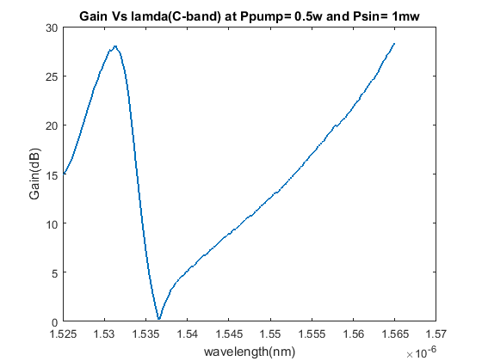

## Psout with ASE Vs lamda(C-band):

pp=zeros(1,401);  
pp(301)=0.001;  
for n=1:1:length(x)  
P=[0.5 pp(n)];  
[l,pn] = ode45(@(l,pn) dP_dzn(l,pn,x(n),y(n),z(n),lamda,segmae,segmaa),(1:50),P);  
pnoise=[pnoise pn(maxIndexp,2)];  
pnoisedB=10*log10(pnoise);  
end  
figure  
loglog(x,pnoisedB,'linewidth',1.5)  
xlabel('wavelength(nm)');  
ylabel('Optical power(dBm)');  
title('Psout with ASE Vs lamda(C-band)')



[*Published with MATLAB® R2016a*](http://www.mathworks.com/products/matlab)